What is Process Scheduling in OS?
Process scheduling is the activity of deciding which process should be performed first (or when), based on a particular strategy/ algorithm. This activity is performed by the process manager; as it removes an active process from the CPU and selects another from the queue. The need for scheduling in OS arises since most applications are multi-programing, i.e. they allow for multiple processes to be loaded and shared with the CPU at a point in time. The manager needs to make the decision on which of these processes must be performed first.
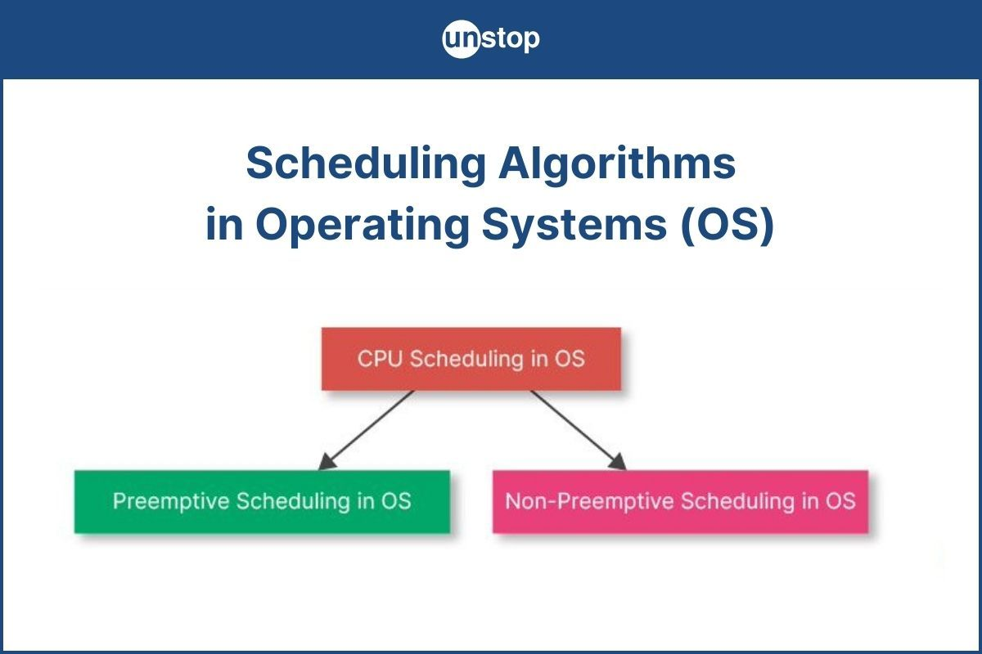
The three major process scheduler types are as follows:
- Long-term job scheduler
- Medium-term scheduler
- CPU or short-term scheduler
Another component of process scheduling is the process queues. All the programs and processes in the system are split up into queues as follows:
- Job queue- All the programs in the system stay in this queue before they are up for execution.
- Ready queue- The programs that are ready to be executed remain in this queue; just before they are picked up for execution.
- Device queue- This queue consists of the processes that have been blocked due to a lack of input/output (I/O) device.
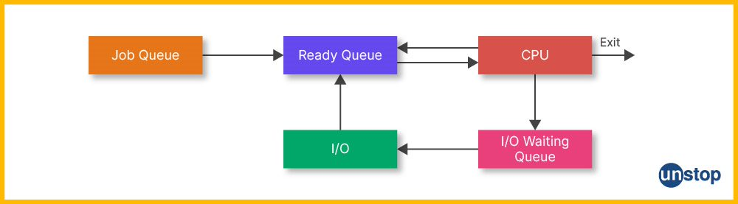

The Need for Process Scheduling in OS
- As mentioned before, there are numerous programs in the operating system (OS) that are in queue for execution at any given point in time. The OS must launch these programs, then stop them, and switch to another program for smooth functioning. A process scheduler is needed to help the OS ascertain which program to run, and when to stop and switch.
- Scheduling allows the OS to allocate CPU time for each process depending upon a predecided strategy/ algorithm.
- Process scheduling also helps the CPU to stay busy at all times thus making sure that the OS utilizes CPU time to the optimum.
- This in effect minimizes time wastage and also that the time a program has to wait to be executed is as short as possible.
- It is needed to ensure that the turnaround time for a process to complete execution is minimized.
- It also reduces or minimizes the response time for the programs.

